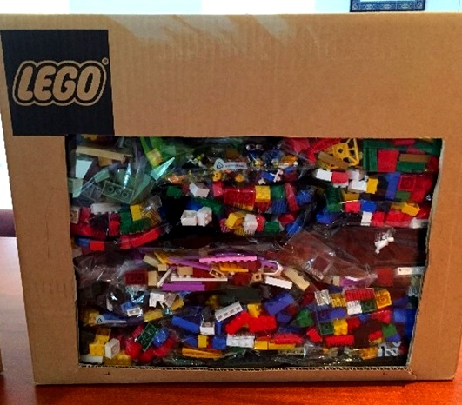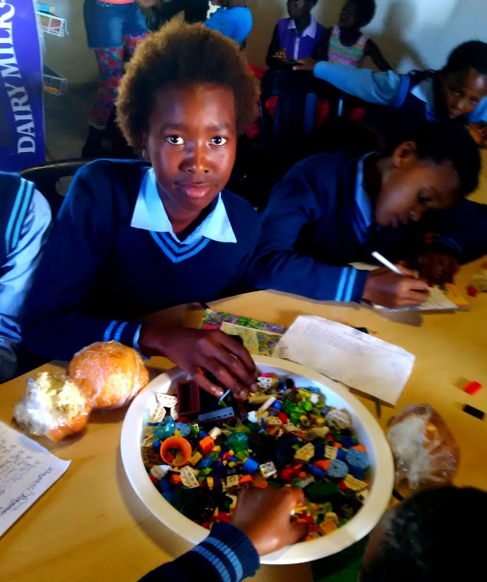LEGO® Charity Box

Classroom Management Tips

Written in partnership with

U:\Hello Monday\Jobs\5426_PowerPoint skabelon til Lego Foundation\Received\work\LEGO Foundation_RGB.emf

Who is this guide for?

This guide is intended for school teachers or those working in an educational organisation, with Grade 4 – 9 students. If you are using the box outside of the classroom or for free play, it does not need to be sorted. If you work with younger children, we suggest that you rather apply for a DUPLO® Charity Box and contact Care for Education for relevant training and materials.

What does the box contain?

LEGO® Charity Boxes consist of new LEGO bricks and elements selected from unused return goods, faultily packaged goods, obsolete elements and more. The content of the LEGO Charity Boxes vary from shipment to shipment. However, in each box there a number pre-ordered bags to ensure that there are enough basic bricks and base plates. The rest of the box has a random selection of figures, technical elements, wheels and other elements. Building instructions and labels are not included in the boxes.

What learning areas or subjects can the box be used for?

The box can be used in all learning areas, right across the curriculum. We have teaching ideas available for maths, technology, social sciences and language teaching as well as ideas for how to use the LEGO pieces for teamwork, fun activities and the development of creative and problem-solving skills.

Suggestions for sorting and storing:

* Store the LEGO pieces in plastic boxes in order to protect them
* If students are going to be using the bricks on their desks rather than on the floor, we suggest using wide, shallow boxes or plastic trays to prevent it from falling off the desks

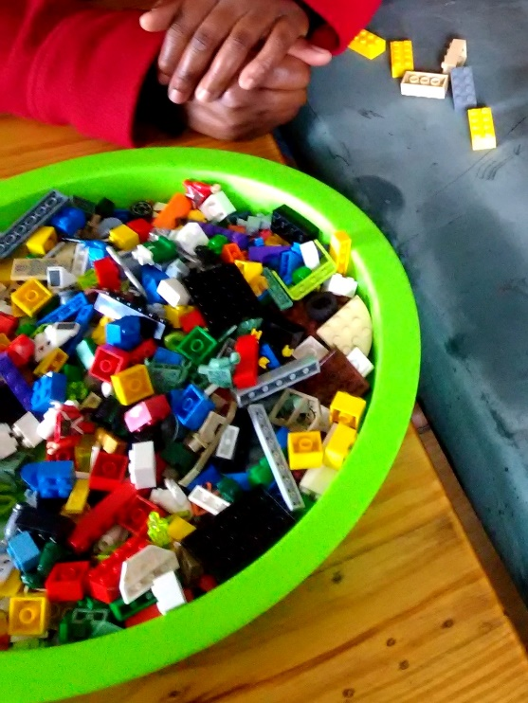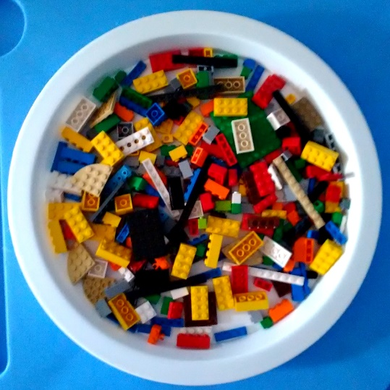

* If the LEGO® elements are going to be used in different learning areas, we suggest dividing up the pieces in the box as follows:
  + 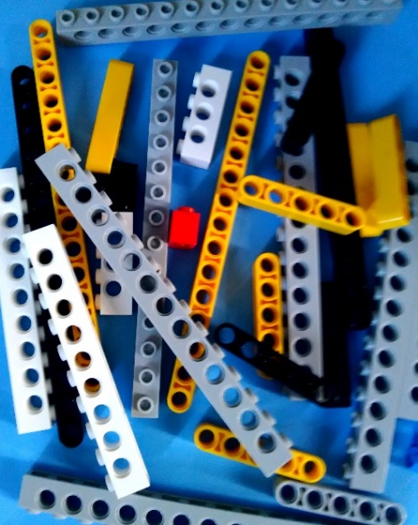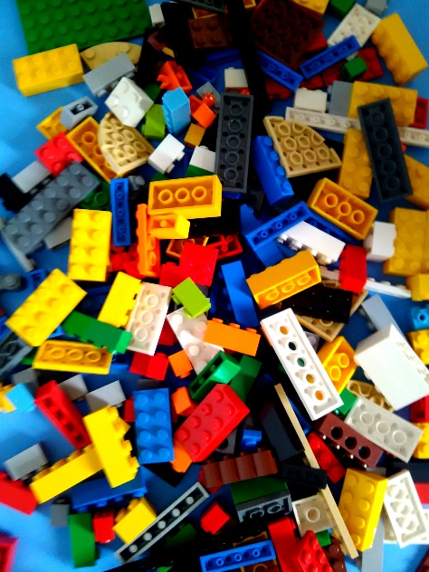Bricks, plates and straight Technic beams - Maths, technology & social sciences

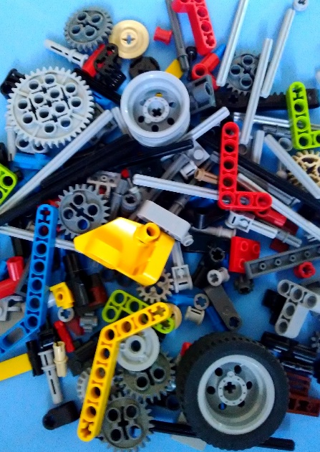

* + Other Technic elements – Technology
  + 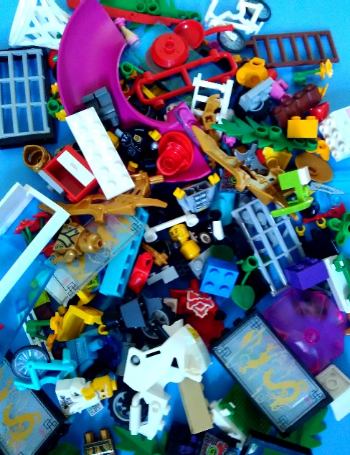Minifigures and creative elements - Languages, games & life orientation

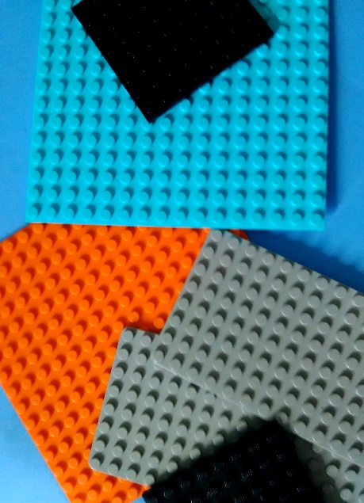

* + Base plates – All learning areas
* Don’t over-sort the boxes. Experience has shown that the LEGO® pieces get used more effectively when they do not require extensive sorting and lessons are easy to prepare for. The only elements that are possibly worth sorting further are some of the elements needed for technology lessons such as gears, wheels, axles, pulleys and beams.
* Store the LEGO boxes inside classrooms rather than in a storeroom where they may be forgotten. If you are concerned about security in classrooms, we suggest putting padlocks on the boxes rather than removing them.
* 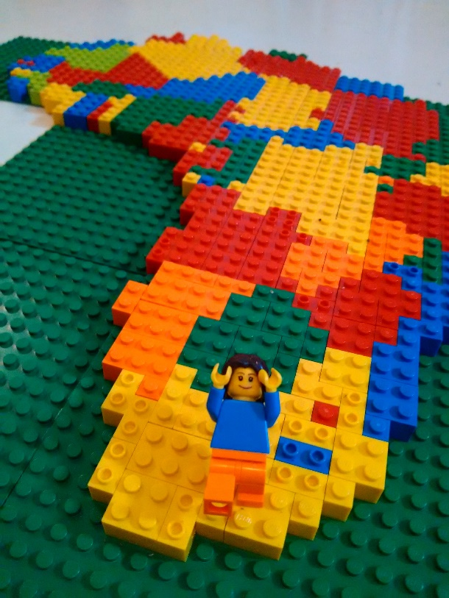Have fun! The possibilities are endless…